Ibn Sina University
College of Computer Science and Information Technology

🇾🇪 Cyber Sheba
A Journey Through Yemen's Beauty
Web Design Final Project Report

Prepared by | Haneen Abdulwasea | ID: 61000229
 | Mona Nasser | ID: 61000319
Instructor | Dr. Afrah
Academic Year | 2025–2026
Submission Date | May 2026

Table of Contents

1. Introduction 3
1.1 Project Motivation 3
1.2 Project Objectives 3
2. Planning 4
2.1 Site Map 4
2.2 Wireframe Descriptions 4
Global Layout 4
Home (index.html) 4
About (about.html) 4
Destinations (destinations.html) 5
Gallery (gallery.html) 5
Contact (contact.html) 5
Blog (Blog_announcement.html) 5
3. HTML Implementation 6
3.1 File Structure 6
3.2 Shared HTML Skeleton 6
3.3 Key HTML Features 7
Semantic Elements 7
Navigation 7
Responsive Meta Tag 7
Image Handling 7
External Fonts — Blog Page 7
4. CSS Implementation 8
4.1 Global Stylesheet (style.css) 8
4.2 CSS Custom Properties (Design Tokens) 8
4.3 Layout Techniques 8
CSS Grid 8
Flexbox 9
Hover Effects & Transitions 9
4.4 Responsive Design 9
4.5 Hero Section 9
5. Website Screenshots 10
5.1 Bab al-Yaman — Gateway to the Old City 10
5.2 Hadramaut — Valley and Heritage 10
5.3 Ibb — The Green Province 11
5.4 Marib Dam — Ancient Engineering Marvel 12
5.5 Sana'a Old City 12
5.6 Socotra Island — The Galápagos of the Arabian Sea 13
6. Challenges and Solutions 14
6.1 Stylesheet Consistency Across Pages 14
6.2 Image Filename Discrepancies 14
6.3 Responsive Layout for Gallery 14
6.4 Blog Page Integration 14
6.5 Hero Background on Different Screen Sizes 15
7. Conclusion 15
8. References 16

1. Introduction
Cyber Sheba is a digital tourism blog dedicated to showcasing the remarkable beauty, rich history, and vibrant cultural heritage of Yemen. The project name draws inspiration from the ancient Kingdom of Sheba (Saba), one of antiquity's most storied civilisations, whose heartland lay in what is now Yemen.

This report documents the full design and development process of the Cyber Sheba website, a six-page multi-file HTML/CSS project submitted as the Web Design Final Project for the College of Computer Science and Information Technology at Ibn Sina University.

1.1 Project Motivation
Yemen possesses a wealth of UNESCO World Heritage sites, extraordinary biodiversity, ancient engineering marvels, and breathtaking natural landscapes that remain largely unknown to the wider world. The Cyber Sheba project aims to bridge this gap by presenting these treasures through a modern, visually compelling web experience.

1.2 Project Objectives
- Promote Yemeni tourism by highlighting exceptional destinations.
- Document cultural and architectural heritage for future generations.
- Demonstrate practical web-development skills using HTML5 and CSS3.
- Inspire a positive and vivid image of 'Happy Yemen' for global audiences.

2. Planning

2.1 Site Map
The website follows a flat, six-page architecture. Every page is reachable from the global navigation bar, ensuring low cognitive load and easy exploration.

Home | About | Destinations
Gallery | Contact | Blog

2.2 Wireframe Descriptions

Global Layout
Every page shares the same three-zone layout:
- Header — deep-red background bearing the site logo and tagline.
- Navigation bar — dark-red strip with six anchor links.
- Footer — dark grey strip with copyright text.

Home (index.html)
A full-width hero section featuring a background image of Shibam overlaid with a dark-red gradient, a bold headline ('Happy Yemen'), a short tagline, and two call-to-action buttons. Below the hero, a four-column feature grid presents the site's key themes: Ancient Cities, Unique Nature, Rich Culture, and Visual Stories.

About (about.html)
A two-column grid: the left column contains descriptive text about the project; the right column contains a styled card listing the four project goals. A team section below introduces the two developers with avatar cards.

Destinations (destinations.html)
Six destination cards arranged in a responsive auto-fit grid. Each card has a coloured header with an icon, a description, UNESCO badge where applicable, keyword tags, and a 'See Photos' link.

Gallery (gallery.html)
A three-column grid of image cards set against a Yemeni-flag gradient background (red / white / black). Each card displays a photograph, a title, and a short description.

Contact (contact.html)
A simple form with Name, Email, and Message fields and a Send button. The page intentionally keeps a minimal layout, relying on the shared stylesheet for visual consistency.

Blog (Blog_announcement.html)
A standalone announcement page with its own dark-red radial gradient hero, distinct typography (Playfair Display), a features list, and two prominent CTA buttons linking back to the main site.

3. HTML Implementation

3.1 File Structure
The project consists of the following files:

File | Purpose
index.html | Homepage with hero section and feature grid
about.html | Project mission, goals, and team section
destinations.html | Six destination cards with details and tags
gallery.html | Photo gallery with flag-inspired background
contact.html | Simple contact form
Blog_announcement.html | Standalone blog launch announcement
style.css | Global stylesheet shared across all pages
*.jpg (10 images) | Photographs for gallery and destination pages

3.2 Shared HTML Skeleton
All main pages share the following structural pattern:
<!DOCTYPE html>
<html lang="en" dir="ltr">
<head>
<meta charset="UTF-8">
<meta name="viewport" content="width=device-width, initial-scale=1.0">
<title>Cyber Sheba | Page Title</title>
<link rel="stylesheet" href="style.css">
</head>
<body>
<header>...</header>
<nav>...</nav>
<!-- Page-specific content -->
<footer>...</footer>
</body>
</html>

3.3 Key HTML Features

Semantic Elements
The project uses semantic HTML5 elements throughout: <header>, <nav>, <section>, <footer>, and <div> containers with descriptive class names such as .dest-card, .about-grid, and .team-section to aid readability and future maintenance.

Navigation
A shared navigation bar appears on every page. The currently active page is highlighted with the .active class. All links use relative paths for portability. The blog page link correctly points to 'Blog_announcement.html'.

Responsive Meta Tag
All pages include <meta name="viewport" content="width=device-width, initial-scale=1.0"> to ensure correct rendering on mobile devices.

Image Handling
Gallery images are referenced using relative paths matching the filenames in the project directory (e.g., lbb_001.jpg, socotra_000.jpg). Images in the gallery and destination cards use object-fit: cover to maintain consistent dimensions regardless of source aspect ratio.

External Fonts — Blog Page
The Blog announcement page imports Google Fonts (Playfair Display and Inter) via a <link> tag to deliver premium typographic styling distinct from the main site.

4. CSS Implementation

4.1 Global Stylesheet (style.css)
The shared stylesheet establishes the visual identity across all pages. Key global rules include:
- Font family: Segoe UI, Tahoma, Geneva, Verdana, sans-serif.
- Background colour: #f4f1ea (warm cream).
- Header: deep red (#b30000) with white text, 30px padding.
- Navigation: darker red (#8b0000) with white links that turn yellow (#ffeb3b) on hover.
- Footer: dark grey (#333) with white text.

4.2 CSS Custom Properties (Design Tokens)
The more advanced pages (index, about, destinations) extend the global stylesheet with CSS custom properties declared on :root, creating a consistent design-token system:
--red: #c0392b;
--red-dark: #8b1a1a;
--red-deep: #5c0a0a;
--gold: #c9a84c;
--cream: #f9f5ee;
--white: #ffffff;
--gray: #555555;
--dark: #1a1a1a;
--radius: 12px;
--transition: 0.25s ease;
--shadow-sm: 0 2px 12px rgba(0,0,0,0.07);
--shadow-md: 0 6px 28px rgba(0,0,0,0.12);
--shadow-lg: 0 12px 48px rgba(0,0,0,0.18);

4.3 Layout Techniques

CSS Grid
Grid is used extensively for responsive multi-column layouts:
- Destination cards: grid-template-columns: repeat(auto-fit, minmax(280px, 1fr)).
- About page: two-column grid that collapses to one column below 700px.
- Team section: repeat(auto-fit, minmax(200px, 1fr)).
- Gallery: fixed three-column grid on desktop, auto-fit on mobile.

Flexbox
Flexbox is used for navigation (justify-content: center; gap: 30px), hero button groups, card headers, and goal items within the About card.

Hover Effects & Transitions
Cards on the destinations, index, and about pages lift on hover using transform: translateY(-8px) combined with box-shadow transitions to create a sense of depth and interactivity. Gallery images scale on hover with transform: scale(1.05).

4.4 Responsive Design
Media queries ensure the layout adapts gracefully to smaller screens:
@media (max-width: 700px) {
.about-grid { grid-template-columns: 1fr; }
}
@media (max-width: 768px) {
.container {
grid-template-columns: repeat(auto-fit, minmax(200px, 1fr));
}
}

4.5 Hero Section
The homepage hero blends a CSS linear-gradient overlay with a background image of Shibam, creating a dramatic full-viewport introduction. A clip-path ellipse at the bottom provides a soft wave transition into the content area below:
.hero::after {
content: "";
position: absolute;
bottom: -1px; left: 0; right: 0;
height: 60px;
background: var(--cream);
clip-path: ellipse(60% 100% at 50% 100%);
}

5. Website Screenshots
The following section presents photographs of Yemen's featured destinations that form the visual backbone of the Cyber Sheba website.

5.1 Bab al-Yaman — Gateway to the Old City
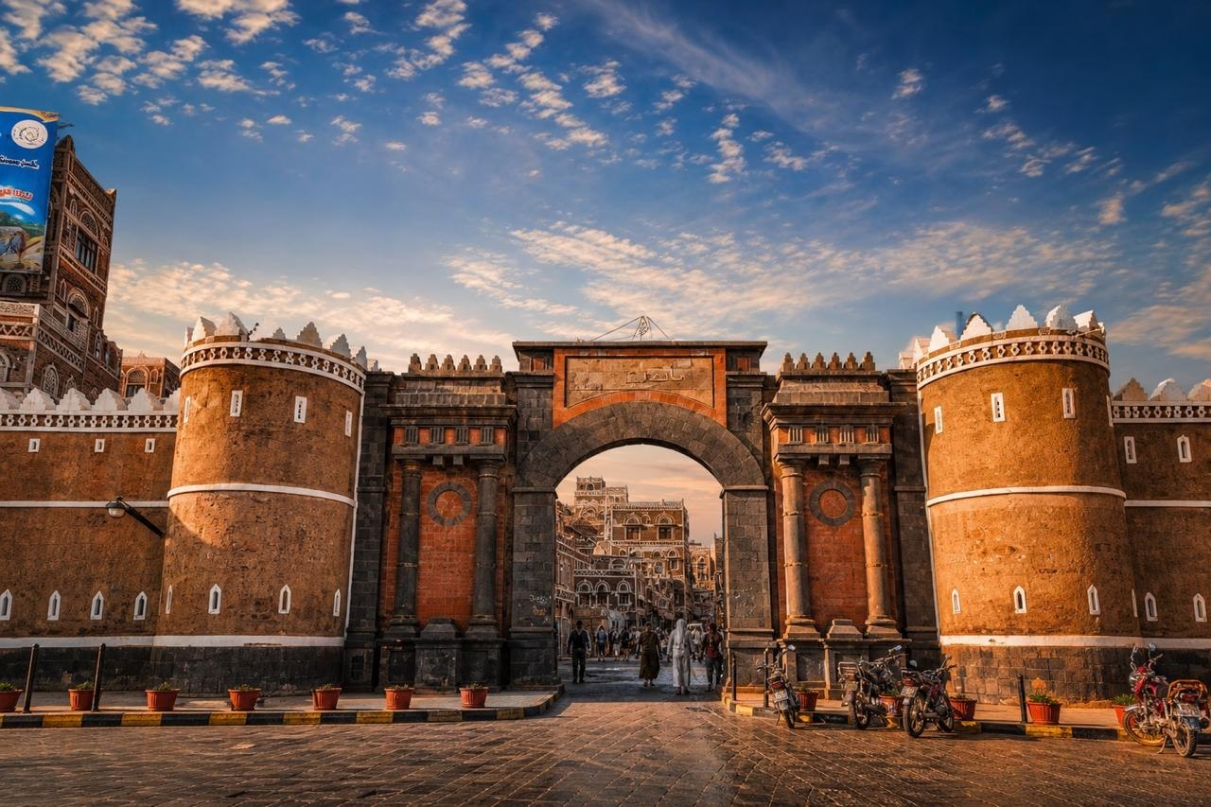
Figure 1: Bab al-Yaman (Gate of Yemen), Sana'a
The iconic Bab al-Yaman serves as the grand arched entrance to the UNESCO-listed Old City of Sana'a. With its twin cylindrical towers, carved stonework, and crenellated battlements, the gate has stood for over a millennium as a symbol of Yemeni strength and craft.

5.2 Hadramaut — Valley and Heritage
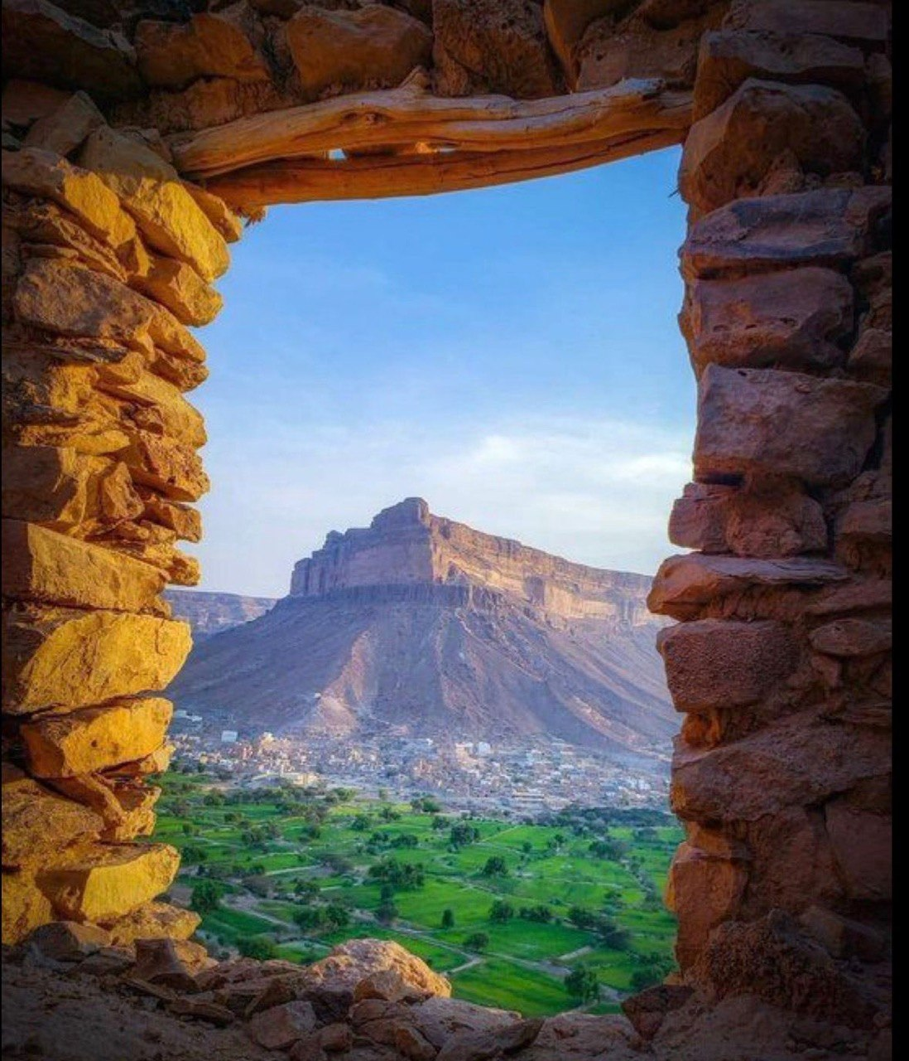
Figure 2: Hadramaut landscape viewed through an ancient stone window
A breathtaking view through a stone-framed window reveals the Hadramaut valley: lush green farmland at the foot of sheer sandstone cliffs, a small town nestled in the valley floor, and a dramatic flat-topped mesa rising against a pale sky.

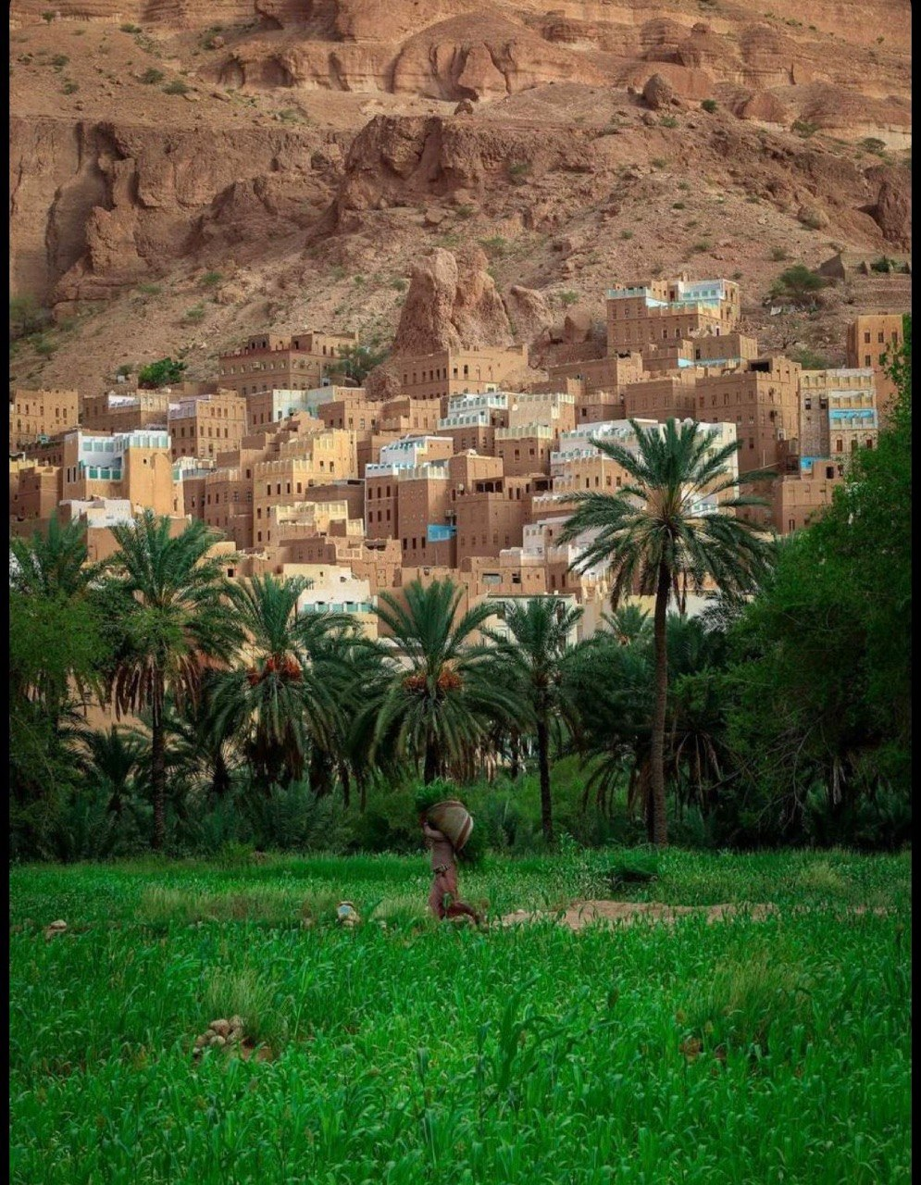
Figure 3: Traditional mud-brick tower houses of Hadramaut
Dense clusters of multi-storey mud-brick tower houses rise above palm groves and green cultivation terraces. This architectural tradition, unique to the Hadramaut region, represents centuries of vernacular engineering adapted to the desert environment.

5.3 Ibb — The Green Province
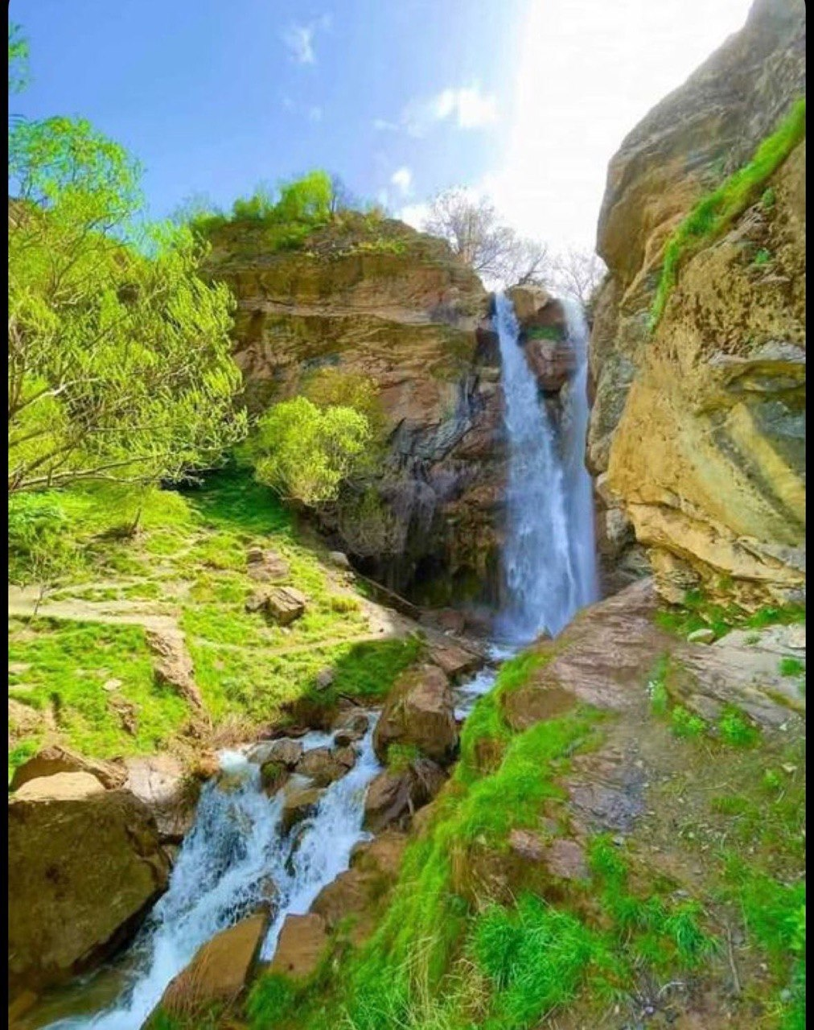
Figure 4: Cascading waterfall in the mountains of Ibb
Yemen's greenest governorate surprises visitors with rushing waterfalls, moss-covered rocks, and dense tree cover. Ibb's mountainous terrain captures monsoon rainfall, producing a lush landscape rarely associated with the Arabian Peninsula.

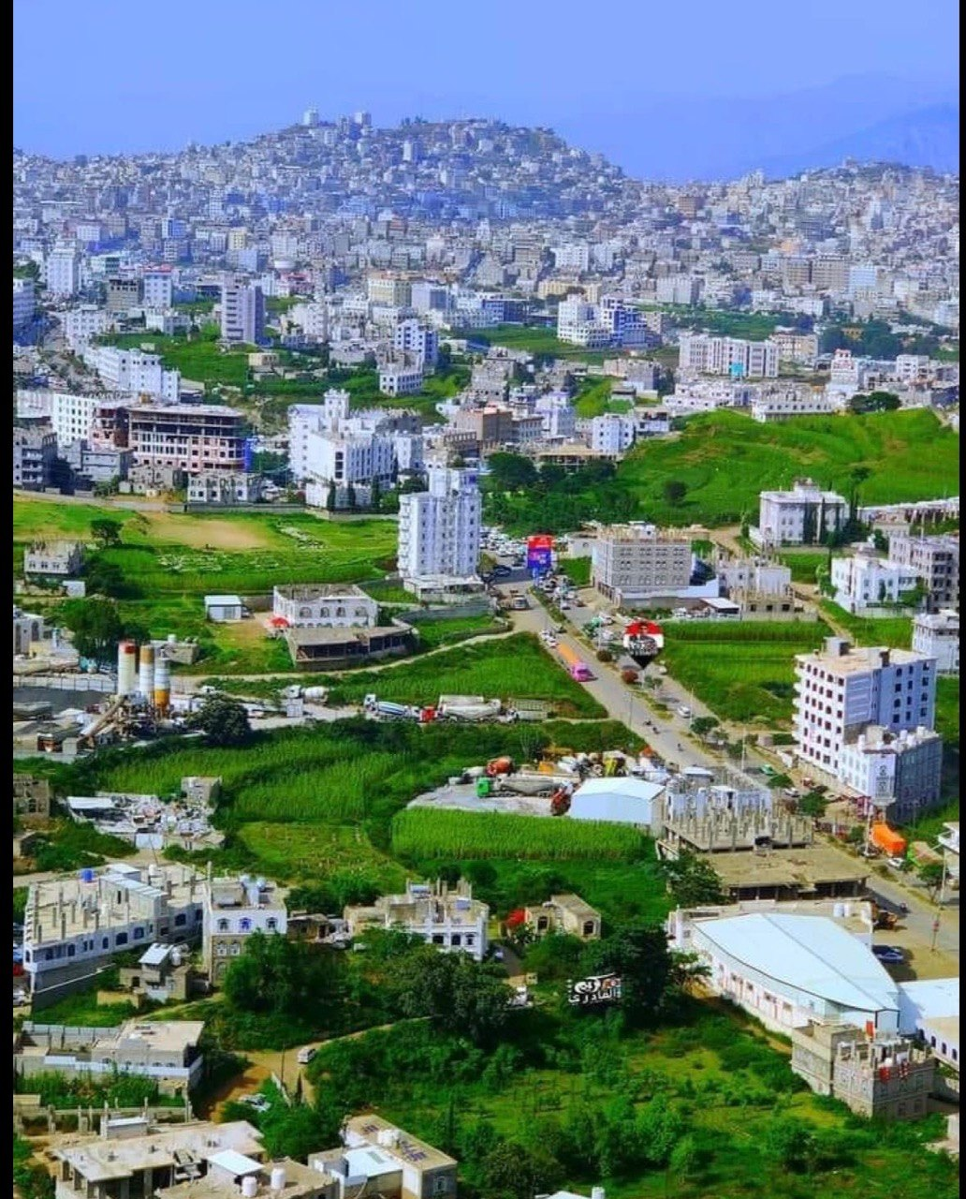
Figure 5: Aerial view of Ibb city amid verdant hills
An aerial perspective of Ibb city shows white modern buildings interspersed with agricultural plots, terraced hillsides, and densely vegetated slopes — a living testament to why the region earned its 'Green Province' nickname.

5.4 Marib Dam — Ancient Engineering Marvel
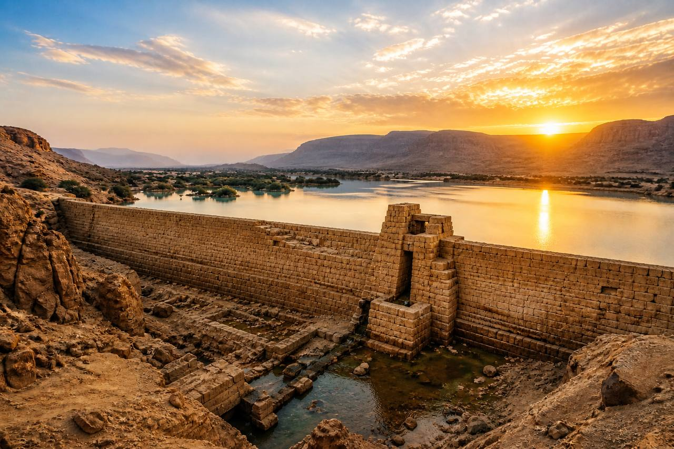
Figure 6: The ancient Great Dam of Marib at sunset
The Great Dam of Marib, originally constructed in the 8th century BC, once fed a vast irrigation network that supported the flourishing Kingdom of Saba. This golden-hour photograph captures the ancient stone spillway and reservoir against a dramatic sunset sky.

5.5 Sana'a Old City
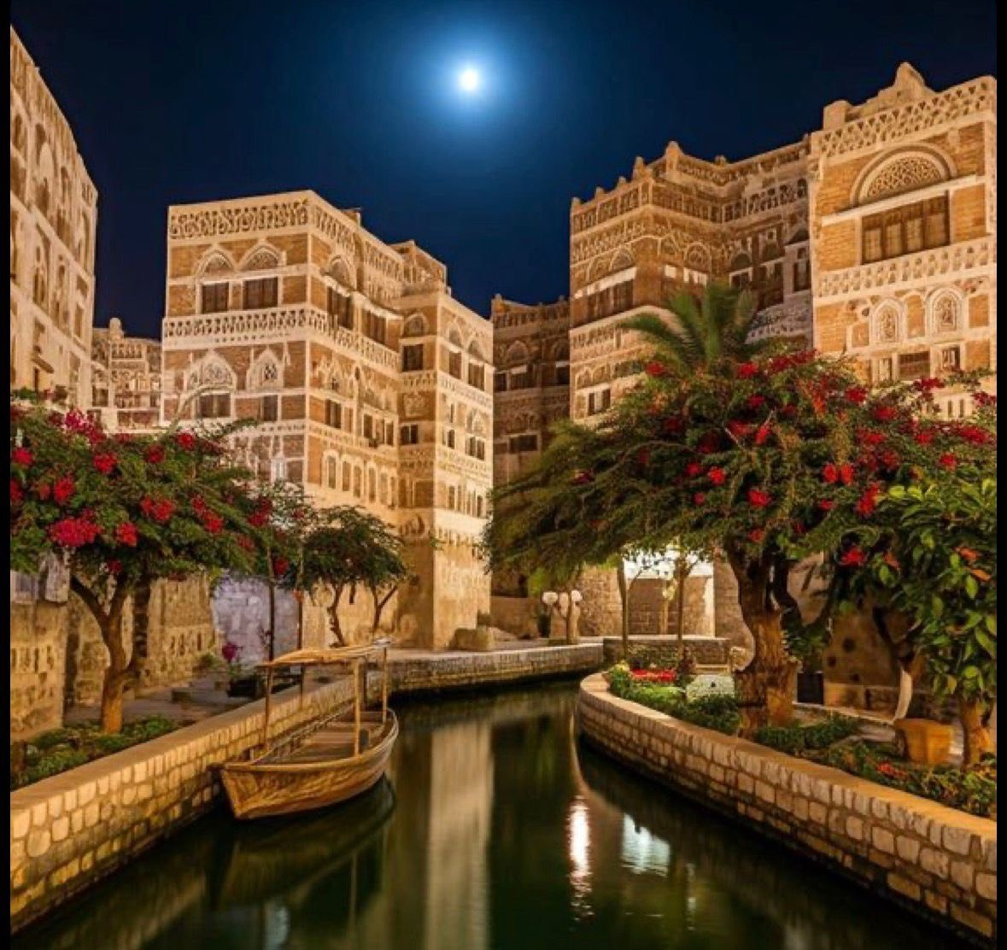
Figure 7: Ornate tower houses of Old Sana'a by moonlight
By moonlight, the intricately decorated tower houses of the Old City reveal their full splendour. Multi-storey buildings clad in fired brick, white gypsum friezes, and alabaster qamariyya windows line a canal-side alley, evoking Old Sana'a's timeless atmosphere.

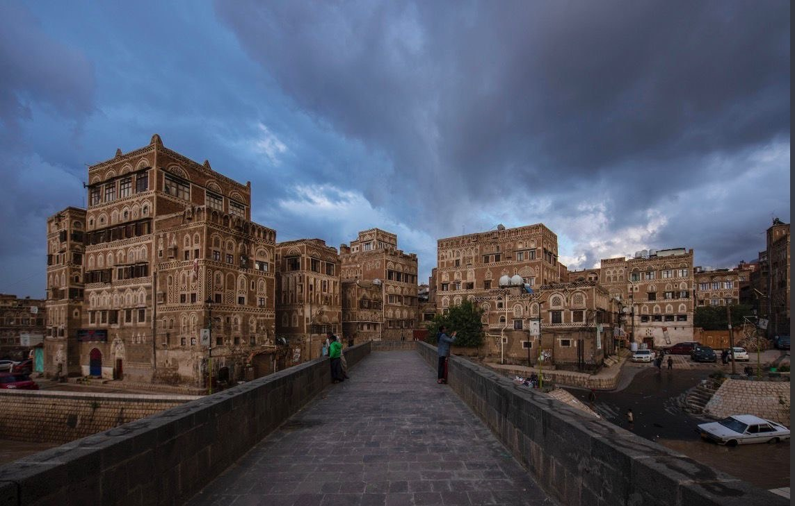
Figure 8: Sana'a's UNESCO streetscape under a stormy sky
A dramatic overcast sky frames the characteristic tower houses of the UNESCO-listed Old City. The buildings' unique geometric decoration — white stucco applied over dark brick — makes this streetscape one of the most distinctive urban landscapes in the world.

5.6 Socotra Island — The Galápagos of the Arabian Sea
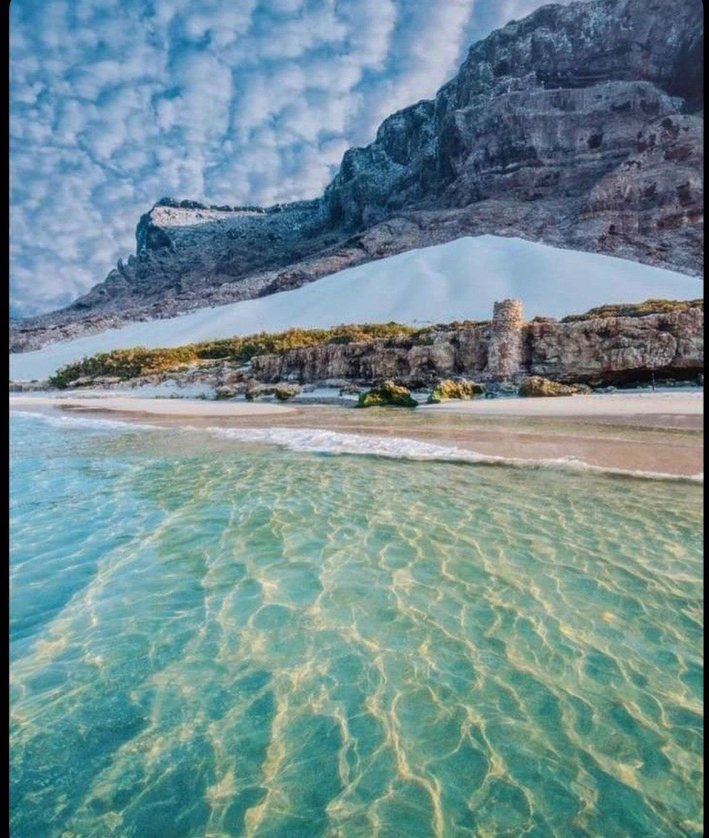
Figure 9: Crystal-clear waters and white-sand beach, Socotra
Socotra's pristine coastline features turquoise water of extraordinary clarity, white-sand shores, and dramatic cliff faces — a UNESCO-protected natural paradise that draws divers and nature lovers from around the world.

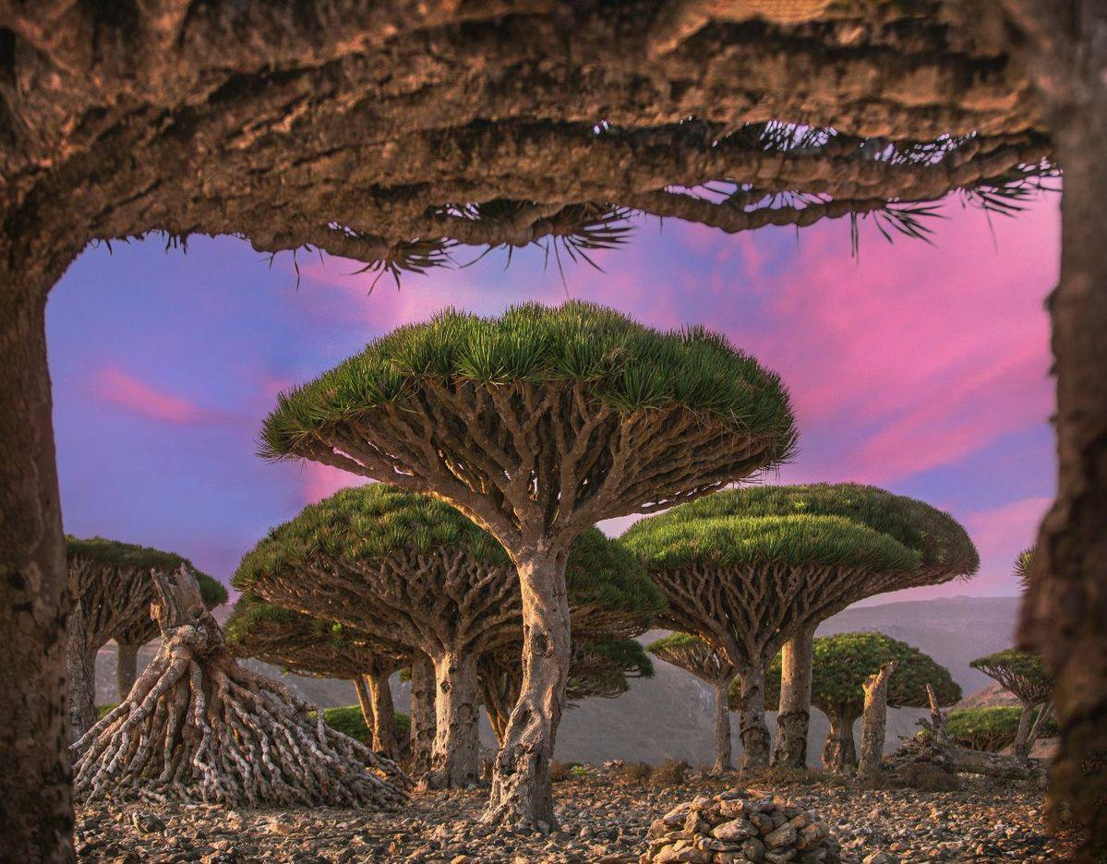
Figure 10: Dragon Blood Trees at dusk, Socotra Island
The iconic Dragon Blood Tree (Dracaena cinnabari), unique to Socotra, forms an otherworldly canopy silhouetted against a magenta and violet sky. These ancient, umbrella-shaped trees produce a crimson resin historically prized for medicine and dye.

6. Challenges and Solutions

6.1 Stylesheet Consistency Across Pages
Challenge: Ensuring a uniform visual identity when individual pages required unique layouts (e.g., the flag-gradient background on the gallery page) alongside the shared stylesheet.

Solution: All pages link to style.css for global rules. Page-specific overrides are placed inside a <style> block within each page's <head>, following the cascade hierarchy so global rules remain intact.

6.2 Image Filename Discrepancies
Challenge: During development, image references in gallery.html contained spaces (e.g., 'hadramaut 001.jpg') and incorrect capitalisation that caused broken image links.

Solution: All image filenames were standardised to use underscores (hadramaut_001.jpg) and lowercase letters, and all HTML src attributes were updated accordingly.

6.3 Responsive Layout for Gallery
Challenge: The gallery page originally used a fixed three-column grid that overflowed on narrow screens.

Solution: A media query at 768px switches the gallery container to repeat(auto-fit, minmax(200px, 1fr)), allowing cards to reflow naturally on mobile devices.

6.4 Blog Page Integration
Challenge: The Blog announcement page was designed with a completely different visual style (dark radial gradient, distinct fonts) and needed to coexist with the rest of the site without style conflicts.

Solution: Blog_announcement.html uses entirely self-contained inline <style> rules and its own font imports, deliberately not linking to style.css. The navigation on all other pages correctly references this file by its exact name.

6.5 Hero Background on Different Screen Sizes
Challenge: The hero section background image could appear cropped or misaligned on wide or tall viewports.

Solution: The background is set to background-size: cover; background-position: center; ensuring the most visually important part of the image remains centred regardless of viewport dimensions.

7. Conclusion
The Cyber Sheba project successfully achieves all of its original objectives. By combining HTML5 semantic structure, a cohesive CSS design system built on custom properties, responsive grid and flexbox layouts, and a carefully curated collection of photography, the website presents Yemen's remarkable heritage in a modern and compelling manner.

The development process reinforced core web-design principles — separation of concerns between structure and style, progressive enhancement through media queries, and the power of consistent design tokens for maintaining visual harmony across multiple pages.

Beyond technical skills, the project carries a deeper significance. In the face of adversity, Cyber Sheba stands as a digital tribute to the resilience and beauty of Yemeni civilisation, inviting the world to discover the ancient cities, extraordinary nature, and warm culture of 'Happy Yemen.'

Future enhancements could include JavaScript-powered interactive features such as a lightbox gallery, an animated map of destinations, multi-language support (Arabic / English), and integration of a dynamic blog using a headless CMS.

8. References
The following resources informed the design, content, and technical implementation of the Cyber Sheba project:

- [1] UNESCO World Heritage List — Yemen. https://whc.unesco.org/en/statesparties/ye
- [2] MDN Web Docs — HTML & CSS Reference. https://developer.mozilla.org
- [3] Google Fonts — Playfair Display & Inter. https://fonts.google.com
- [4] W3Schools — CSS Grid Layout Guide. https://www.w3schools.com/css/css_grid.asp
- [5] CSS-Tricks — A Complete Guide to Flexbox. https://css-tricks.com/snippets/css/a-guide-to-flexbox/
- [6] Socotra Island — UNESCO Natural World Heritage. https://whc.unesco.org/en/list/1263
- [7] Old City of Sana'a — UNESCO Cultural World Heritage. https://whc.unesco.org/en/list/385
- [8] Shibam — UNESCO Cultural World Heritage. https://whc.unesco.org/en/list/192

